Southern Haulage Dressage Day 2011
Sunday 27th February

West Plantagenet Pony Club hosted its first dressage event in Mt Barker with 112 entries. Riders sweltered in the afternoon heat to fiercely contest classes in Preparatory, Preliminary, Novice, Elementary and Prix Caprilli. It was an idealic setting at Frost Oval for spectators to enjoy the fine display of horsemanship. Riders competed in a championship event where they had to ride 3 tests for the day including the Prix Caprilli test with jumps. Champion Pony was awarded to Linda Lycholit riding Geisha and Champion Horse to local rider Ferne Faulkner riding William. The day was generously sponsored by Southern Haulage Industries.

Results: Preparatory 2, 12&under 1st Tiffany Holland on Charmed I’m Sure Conneely, 13-17yrs 1st Bethany Rainbow on Kellerains Danzabet, Over18yrs 1st Ferne Faulkner on William. Preliminary 1B, 12&under 1st Tiffany Holland on Charmed I’m Sure Conneely, 13-17yrs 1st Amy Belinger-Brown on Get Into The Spirit, Over18yrs 1st Kim Bunney on Louisville Gold. Novice 2B, 13-17yrs 1st Indiana Weinert on Beelo Bi Argyle, Over 18yrs 1st Kim Bunney on Louisville Gold. Elementary 3B, 13-17yrs 1st Natasha Verazzi on Farben Façade, Over18yrs 1st Chloe Radford on Wandu Hills Maestro. Prix Caprilli, 12&under 1st Brittany Hoveier on Velvet Lily, 13-17yrs 1st Indiana Weinert on Beelo Bi Argyle, Over18yrs 1st Ferne Faulkner on Stratosphere. Judging Competition 12&under Brittany Hoveier, 13-17yrs Natasha Verazzi, Over18yrs Chloe Radford. Nominate a Partner, 1st Ferne Faulkner & Victoria Squire.

Photos below.

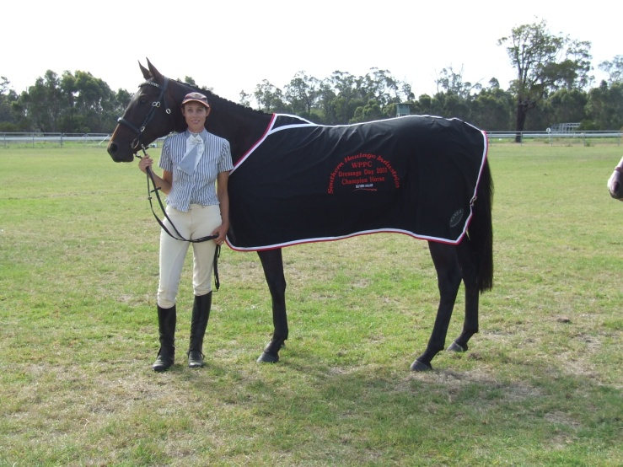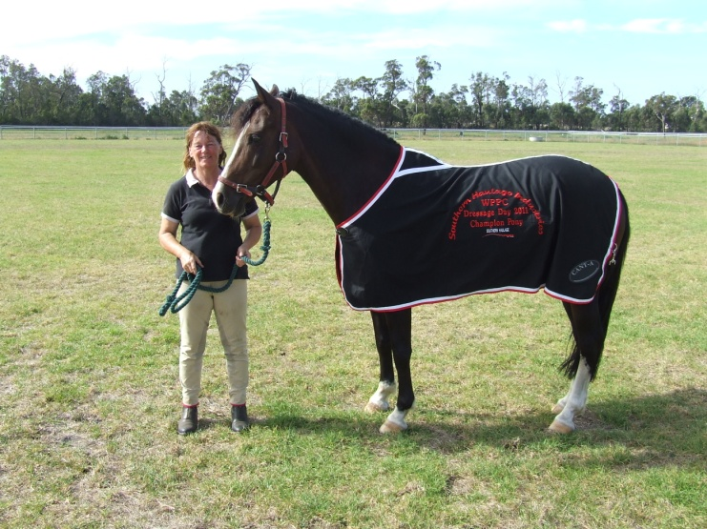
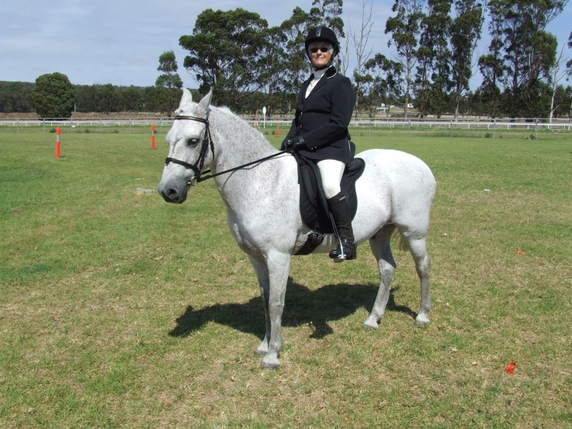
Photos From Top: Champion Horse – Ferne Faulkner on William, Champion Pony - Linda Lycholit on Geisha & Kath Hodskinson on Freckles.

