PCAWA State Eventing Championships 2010 Dardanup
(23rd& 24th October)
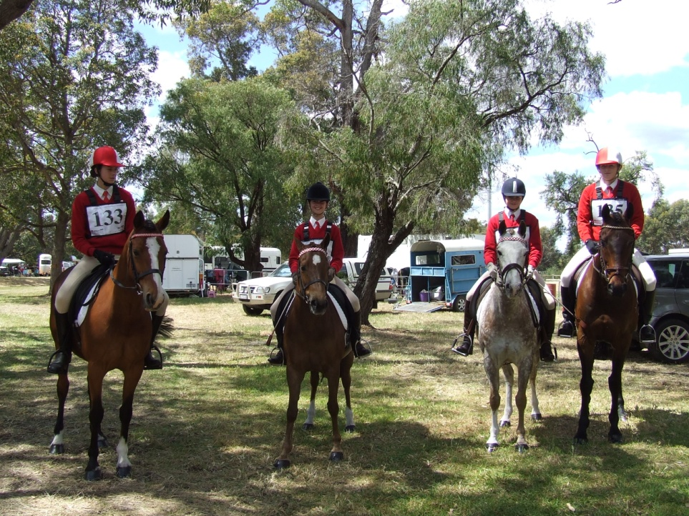

From Left: Tracy Shepherd on Just A Rumour, Edwina Squire on Windrush Symphony, Victoria Squire on Champagn Magnum and Millie Sexton on Permanent Grin.
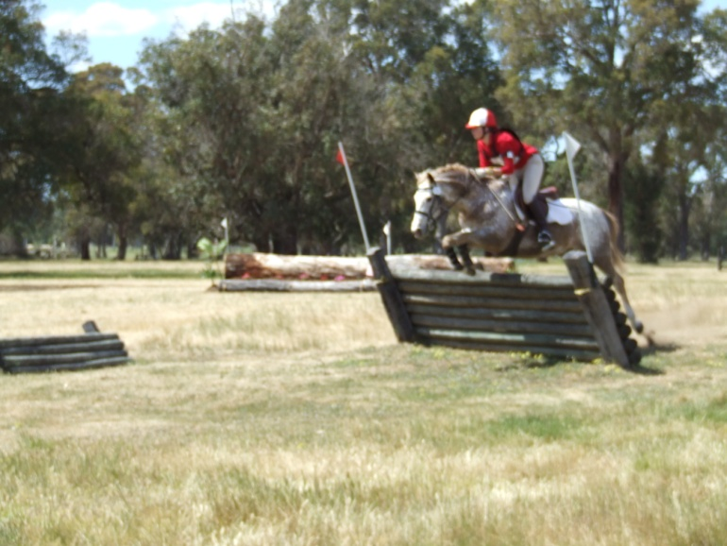
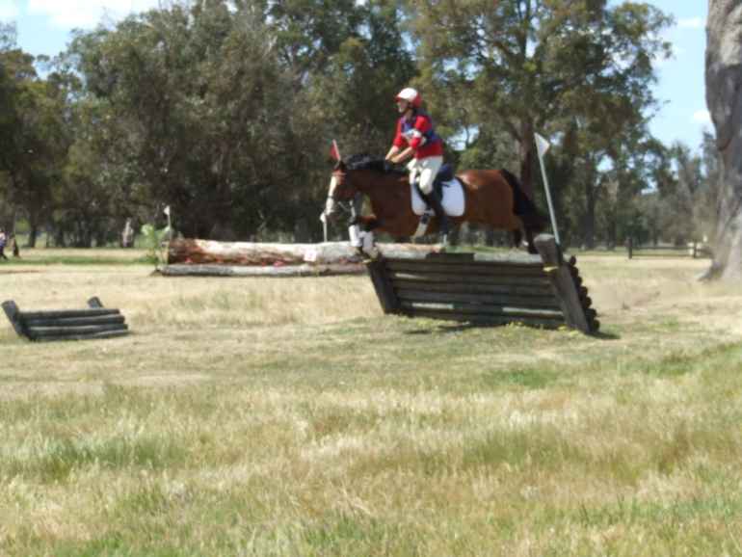
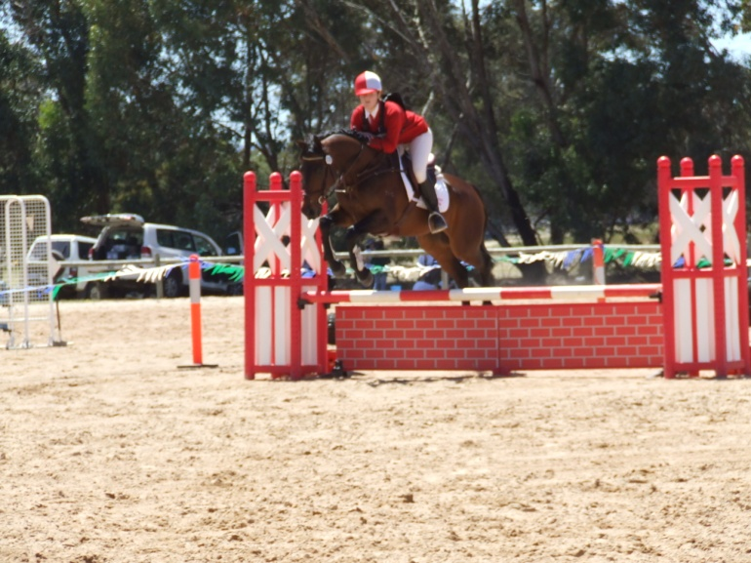

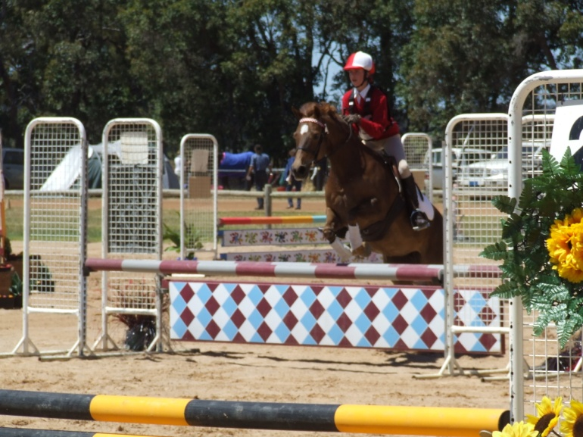

On the weekend of the 23rd & 24th October riders from all over the state converged on Dardanup to compete in the Pony Club Association Of Western Australia, State Eventing Championships 2010. Four riders from the small pony club of West Plantagenet entered C Grade, Millie Sexton, Victoria Squire, Edwina Squire and Tracy Shepherd. The WPPC team came 2nd in C Grade from a field of 21 teams (84 riders).

Here’s what some of the riders thought of the weekend.

‘I enjoyed riding as a team. It was a great cross country course, quite challenging and we all completed the course clear’, Tracy Shepherd 14yo.

‘It was great fun, really enjoyable. Dardanup did a really great job of hosting states and it was a friendly and inviting atmosphere’, Victoria Squire 15yo.

